Lab 1 Task B(part)

Pseudocode task 6

Start

Declare temp, cel;

Input temp, cel(from Fahrenheit to Celsius)

Temp cel=5/9\*(Fahrenheit-32)

Print Temp cel

End

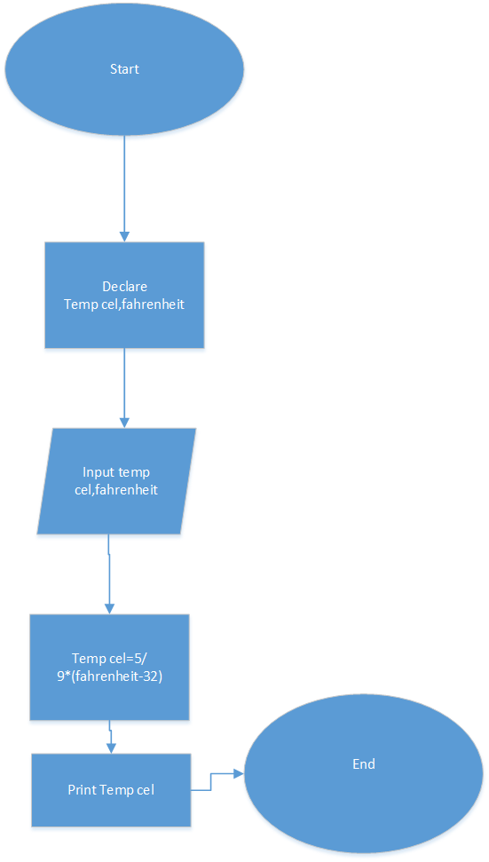

Pseudocode task 7

Start

Declare length,width,perimeter;

Input length,width,perimeter;

Perimeter=2\*(length+width)

Display perimeter

End

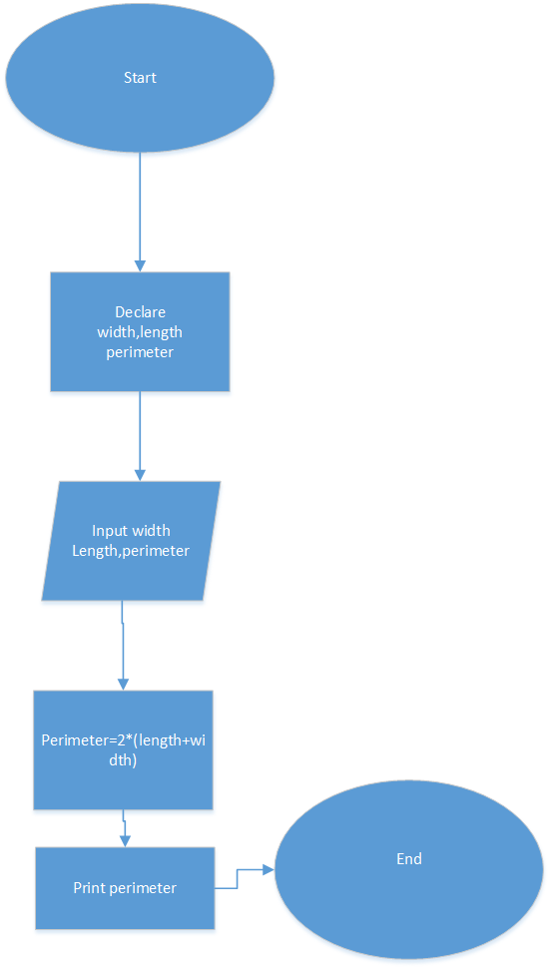pseudeocode task7

start

declare

length,width,

perimeter

input length,width,

perimeter

perimeter=2\*(L+W)

print perimeter

end

Pseudocode task 10

Start

Declare num1,num2,num3

Input num1,num2,num3

Num1=5

Num2=10

(Add 7 to num2)

Num2=10+7

Num2=17

Num3=num1=num2

Num2=num2-num1

Print num1

Print num2

Print num3

End

